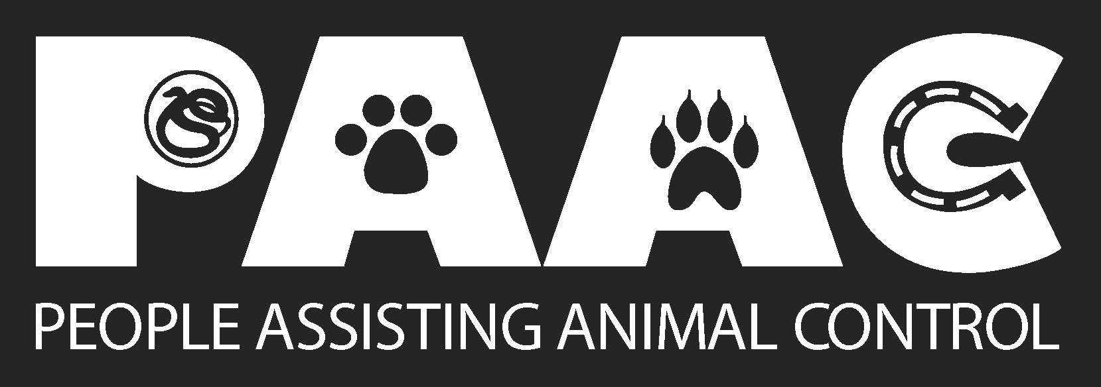

PUT YOUR PAW ON THE WALL OF OUR BUILDING!!
____ $5.00 - $99.00 4 inch
____ $100.00 - $499.00 6 inch
____ $500.00 - $999.00 8 inch
____ $1,000.00 - $4,999.00 10 inch
____ $5,000.00 or over 3 feet

Name:________________________________________________________________________

Name on PAW:_________________________________________________________________
This can be your pet's name, your name, business name, in memory of a pet or loved one.

Address:______________________________________________________________________

City, State, Zip:_________________________________________________________________

Phone: ( )__________________Fax: ( )____________________________

Email:__________________________________________________________

BILLING & PAYMENT INFORMATION: $_________________
□ Make check made payable to PAAC Make payment online at www.ccpaac.org
□ Charge my credit card PAID:____________; by___________

Cardholder Name:__________________________________________________

Billing Address:____________________________________________Zip Code:__________

Card #:______________________________Expires____________Date:_____/______/_______

PAAC is a 501c3 nonprofit organization and all donations are tax deductible.

